Вариант 14 [2,4,6,10,12,(8,9,11,13,15)]
№ вх.  набора | x₃ | x₂ | x₁ | x₀ | y
0 | 0 | 0 | 0 | 0 | ~
1 | 0 | 0 | 0 | 1 | ~
2 | 0 | 0 | 1 | 0 | 1
3 | 0 | 0 | 1 | 1 | ~
4 | 0 | 1 | 0 | 0 | 1
5 | 0 | 1 | 0 | 1 | ~
6 | 0 | 1 | 1 | 0 | 1
7 | 0 | 1 | 1 | 1 | ~
8 | 1 | 0 | 0 | 0 | 0
9 | 1 | 0 | 0 | 1 | 0
10 | 1 | 0 | 1 | 0 | 1
11 | 1 | 0 | 1 | 1 | 0
12 | 1 | 1 | 0 | 0 | 1
13 | 1 | 1 | 0 | 1 | 0
14 | 1 | 1 | 1 | 0 | ~
15 | 1 | 1 | 1 | 1 | 0

----------------------------------------------------------------------------------------------------------------
Y_{сднф} = x₃ x₂ x₁ x₀ v x₃ x₂ x₁ x₀ v x₃ x₂ x₁ x₀ v x₃ x₂ x₁ x₀ v x₃ x₂ x₁ x₀ v x₃ x₂ x₁ x₀ v x₃ x₂ x₁ x₀ v
№ набора 0 1 2 3 4 5 6

x₃ x₂ x₁ x₀ v x₃ x₂ x₁ x₀ v x₃ x₂ x₁ x₀ v x₃ x₂ x₁ x₀
№ набора 7 10 12 14

----------------------------------------------------------------------------------------------------------------
Склеивание наборов: 0-1, 2-3, 4-5, 6-7, 10-14, 12

Y_{сднф} = x₃ x₂ x₁ v x₃ x₂ x₁ v x₃ x₂ x₁v x₃ x₂ x₁ v x₃ x₁x₀ v x₃ x₂ x₁ x₀
№ пар 1 2 3 4 5 6

----------------------------------------------------------------------------------------------------------------
Повторное склеивание: 1-2, 3-4, 5-6

Y_{сднф} = x₃ x₂ v x₃ x₂ v x₃(x₁x₀ v x₂ x₁ x₀ ) = x₃ v x₃(x₁x₀ v x₂ x₁ x₀ )

----------------------------------------------------------------------------------------------------------------
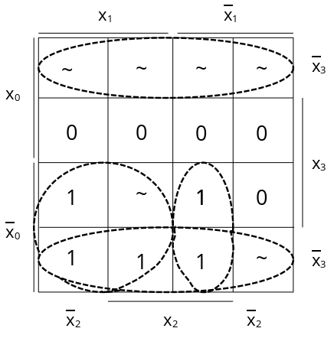

----------------------------------------------------------------------------------------------------------------
Y_{мднф} = x₁ x₀ v x₂ x₁ x₀ v x₃

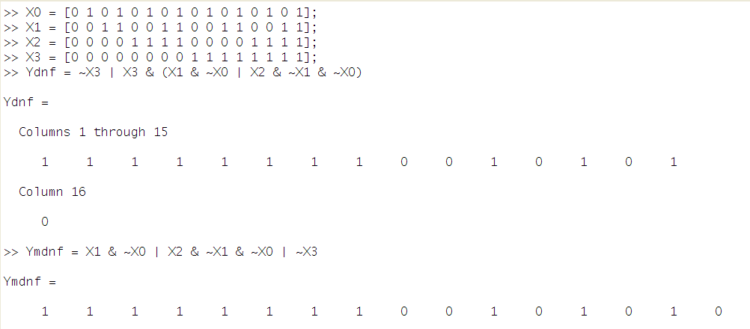

mdnf
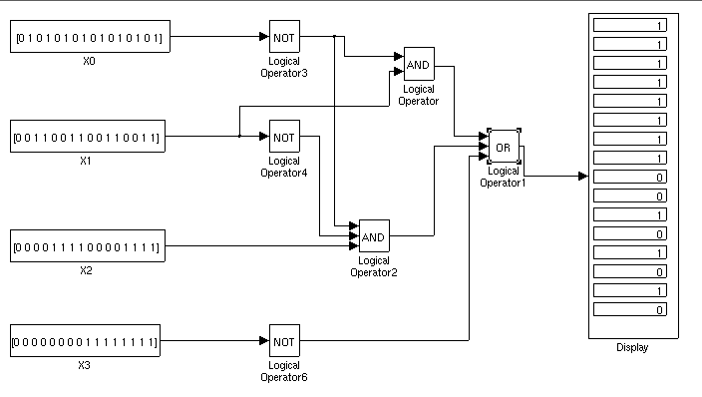

sdnf
